INT-234 PREDICTIVE ANALYTICS
PROJECT REPORT
(Project Semester Aug - Jan 2025)
Predictive Analytics on Telangana Weather Data
Submitted by:
Name of student: Ponnuru Nithin
Registration No: 12303486
Programme and Section: K23MS
Course Code: INT- 234
Submitted by:
Name of faculty: Anchal Kaundal
UId: 29612


School of Computer Science Engineering
Lovely Professional University, Phagwara

CERTIFICATE

This is to certify that Nithin Ponnuru bearing Registration no. 12303486 has completed INT – 234 project titled, Predictive Analytics on Telangana Weather Data. To the best of my knowledge, the present work is the result of his/her original development, effort and study.

Name of the Supervisor: Anchal Kaundal
Signature: Anchal Kaundal
School of Computer Science Engineering
Lovely Professional University
Phagwara, Punjab.

Date: 18-12-2025

DECLARATION

I, Nithin Ponnuru, student of under School of Computer Science Engineering CSE/IT Discipline at, Lovely Professional University, Punjab, hereby declare that all the information furnished in this project report is based on my own intensive work and is genuine.

Name of the student: Nithin Ponnuru
Registration No: 12303486
Date: 18-12-2025
Signature: P. Nithin

ACKNOWLEDGEMENT:
I would like to express my sincere gratitude to all those who contributed, directly or indirectly, to the successful completion of this Predictive Analytics project on Telangana Weather Data. This project has been a valuable learning experience, allowing me to apply theoretical concepts to real-world data and gain practical exposure to data analysis and machine learning techniques.
First and foremost, I would like to express my heartfelt thanks to my course instructor, Mr. Anchal Kaundal, for her constant guidance, encouragement, and support throughout the duration of this project. Her in-depth knowledge of Predictive Analytics, clear explanations, and constructive feedback played a crucial role in shaping this work. She consistently motivated us to explore beyond the classroom syllabus and helped us understand how analytical techniques can be applied to solve practical problems. Her patience and willingness to clarify doubts made the learning process smooth and enriching.
I am also grateful to my institution for providing a conducive academic environment and the necessary resources required to carry out this project. The curriculum of the Predictive Analytics (INT234) course was well structured and offered a strong foundation in data preprocessing, exploratory data analysis, supervised learning, and unsupervised learning. The practical sessions associated with the course helped reinforce theoretical concepts and encouraged hands-on implementation using Python and machine learning libraries.
I would like to acknowledge the Telangana Open Data Portal (https://data.telangana.gov.in/) for making high-quality government weather data publicly available. Access to authentic and reliable real-world data significantly enhanced the relevance and credibility of this project. Working with this dataset helped me understand the challenges involved in real-world data handling, such as missing values, variability, and feature relationships.
I also extend my appreciation to the developers and contributors of open-source libraries such as Python, Pandas, NumPy, Scikit-learn, Matplotlib, and Seaborn, which played a vital role in the implementation of this project. These tools enabled efficient data preprocessing, visualization, model building, and evaluation, making complex analytical tasks more manageable and systematic.
Finally, I would like to thank my peers and friends for their valuable suggestions, discussions, and encouragement throughout the project. Collaborative learning and idea sharing helped me improve problem-solving skills and gain different perspectives on analytical approaches.
In conclusion, this project has greatly enhanced my understanding of predictive analytics and strengthened my interest in data science. The knowledge and experience gained during this work will be invaluable in my future academic and professional endeavors.

Table of Content:
1. Introduction
2. Problem Statement
3. Source of Dataset

4. Dataset Description
5. EDA (Exploratory Data Analysis)
6. Analysis on dataset (for each analysis):
- Introduction
- General Description
- Specific Requirements, Functions, Formulas
- Analysis Results
- Visualization
7. Conclusion
8. Future Scope:
9. References:
10. Code
11. Revision Tracking Github and Linkedin

- INTRODUCTION:
In recent years, the rapid growth of data generation and advancements in computing technologies have made data-driven decision-making an essential component across various domains. Predictive Analytics is a powerful branch of data science that focuses on analyzing historical data to identify patterns, relationships, and trends, and then using these insights to make predictions about future outcomes. By combining statistical techniques, machine learning algorithms, and data visualization, predictive analytics enables organizations and researchers to extract meaningful knowledge from large datasets and support informed decision-making.
Weather prediction is one of the most important real-world applications of predictive analytics. Accurate weather analysis plays a crucial role in agriculture, disaster management, water resource planning, transportation, and public safety. Parameters such as rainfall, temperature, humidity, and wind speed significantly influence environmental conditions and human activities. Even small improvements in understanding weather patterns can help mitigate risks associated with extreme weather events and improve planning efficiency.
This project focuses on the predictive analysis of Telangana weather data, specifically for November 2025, using machine learning techniques. The dataset, obtained from the Telangana Open Data Portal, contains daily weather observations including rainfall, minimum and maximum temperature, humidity levels, and wind speed. Since the dataset is real-world and government-provided, it presents typical data challenges such as variability, noise, and missing values, making it suitable for practical implementation of predictive analytics concepts.
The primary objective of this project is to analyze weather data, predict rainfall behavior, classify rainfall intensity, and identify hidden patterns using both supervised and unsupervised learning techniques. The project follows a systematic data science workflow starting with data preprocessing and exploratory data analysis (EDA). EDA helps in understanding the structure of the data, identifying correlations among variables, and visualizing trends that influence rainfall patterns.
Supervised learning techniques such as Multiple Linear Regression and Polynomial Regression are used to model and predict rainfall based on meteorological factors like temperature, humidity, and wind speed. Additionally, K-Nearest Neighbors (KNN) classification is applied to categorize rainfall into meaningful classes such as no rain, light rain, and moderate rain. These models are evaluated using appropriate performance metrics including R² score, mean absolute error, mean squared error, accuracy, and ROC-AUC to ensure reliable predictions.
Furthermore, the project incorporates unsupervised learning methods such as K-Means Clustering and Hierarchical Clustering to discover underlying patterns and similarities in weather conditions without predefined labels. These techniques help group weather observations with similar characteristics and provide insights into regional or temporal weather behavior.
Overall, this project demonstrates the practical application of predictive analytics concepts taught in the INT234 Predictive Analytics course. It bridges the gap between theory and practice by applying machine learning techniques to real-world weather data, thereby enhancing analytical skills and understanding of data-driven prediction models.

2. PROBLEM STATEMENT:
Weather variability has a significant impact on various sectors such as agriculture, water resource management, disaster preparedness, and daily human activities. In regions like Telangana, where rainfall patterns play a crucial role in agricultural productivity and water availability, understanding and predicting weather behavior is essential. However, weather data is often complex, high-dimensional, and influenced by multiple interrelated factors such as temperature, humidity, and wind speed. Traditional methods of weather analysis may not be sufficient to capture these complex relationships accurately, leading to unreliable predictions and ineffective planning.
The primary challenge addressed in this project is the analysis and prediction of rainfall patterns using historical weather data through predictive analytics techniques. The dataset used in this study consists of real-world weather observations collected from different regions of Telangana during November 2025. Although the dataset provides valuable information, it presents several analytical challenges. These include missing values, variations in measurement scales, non-linear relationships between variables, and the absence of predefined class labels for certain analytical tasks. Such challenges necessitate effective data preprocessing, careful feature selection, and the application of appropriate machine learning algorithms.
Another major problem lies in identifying the most suitable analytical approach for different objectives within the same dataset. Rainfall prediction requires regression-based models capable of handling continuous numerical data, while rainfall intensity classification demands suitable classification techniques. Additionally, discovering hidden patterns or similarities in weather conditions requires unsupervised learning methods. Selecting and implementing the right combination of supervised and unsupervised algorithms is essential to ensure meaningful and interpretable results.
The problem addressed by this project can therefore be summarized as follows: How can predictive analytics techniques be effectively applied to real-world Telangana weather data to accurately predict rainfall, classify rainfall intensity, and uncover underlying weather patterns, while handling data quality issues and ensuring reliable model performance? Addressing this problem requires a structured analytical approach involving data preprocessing, exploratory data analysis, supervised learning for prediction and classification, and unsupervised learning for pattern discovery.

3. SOURCE OF DATASET:
The dataset used in this project was obtained from the Telangana Open Data Portal, an official government platform that provides public access to datasets published by various departments of the Government of Telangana. The portal is designed to promote transparency, data-driven research, and informed decision-making by making reliable and authentic data available to citizens, researchers, and students.
The specific dataset used for this project contains weather-related information for the state of Telangana, covering daily observations for the month of November 2025. It includes meteorological parameters such as rainfall, minimum and maximum temperature, humidity levels, and wind speed recorded across different districts and mandals of the state. Since the data is collected and maintained by government authorities, it ensures a high level of credibility and accuracy, making it suitable for academic and analytical purposes.
The dataset was accessed directly from the Telangana Open Data Portal at the following link:
https://data.telangana.gov.in/.
The data is provided in a structured digital format, which allows easy downloading and integration into analytical tools such as Python. As an open-source government dataset, it can be freely used for educational and research activities without licensing restrictions.
Using a government-provided open dataset adds significant value to this project, as it reflects real-world data characteristics. Unlike synthetic or sample datasets, real-world weather data often contains variability, noise, and missing values, which present practical challenges during data preprocessing and analysis. Working with such data helped in understanding the importance of data cleaning, feature selection, and exploratory data analysis before applying predictive models.

4. DATASET DESCRIPTION:
The dataset used in this project consists of daily weather observations for the state of Telangana during the month of November 2025. It captures essential meteorological parameters that influence weather conditions and rainfall patterns across different regions of the state. The dataset was sourced from the Telangana Open Data Portal, ensuring authenticity and reliability of the recorded data.
Column Name | Data Type | Description
District | Categorical | Name of the district in Telangana where the weather data was recorded
Mandal | Categorical | Administrative subdivision (mandal) within the district
Date | Date | Date on which the weather observation was recorded
Rain (mm) | Numerical | Amount of rainfall recorded in millimeters
Min Temp (°C) | Numerical | Minimum temperature recorded in degrees Celsius
Max Temp (°C) | Numerical | Maximum temperature recorded in degrees Celsius
Min Humidity (%) | Numerical | Minimum relative humidity percentage
Max Humidity (%) | Numerical | Maximum relative humidity percentage
Min Wind Speed (Kmph) | Numerical | Minimum wind speed recorded in kilometers per hour
Max Wind Speed (Kmph) | Numerical | Maximum wind speed recorded in kilometers per hour

5. EDA (EXPLORATORY DATA ANALYSIS) PROCESS:
1. Objective:
The objective of this exploratory data analysis is to study weather characteristics of Telangana and understand how different meteorological factors such as temperature, humidity, and wind speed influence rainfall patterns. The analysis aims to identify trends, relationships, and variations across weather parameters and to prepare the dataset for applying predictive analytics techniques such as regression, classification, and clustering.
2. Data Loading and Initial Inspection:
The dataset is loaded from a CSV file using the pd.read_csv() function. Initial inspection is carried out to understand the structure and quality of the data.
- The shape of the dataset is displayed to know the number of records and attributes.
- The df.info() method provides details about column names, data types, and non-null counts.
- The first five rows of the dataset are displayed using df.head() to understand the format and values of the data.
- A statistical summary is generated using df.describe() to obtain measures such as mean, standard deviation, minimum, maximum, and quartiles for numerical attributes.
This step helps in identifying the nature of the dataset and determining suitable preprocessing techniques.
3. Data Cleaning:
To ensure data quality and consistency, several preprocessing steps are applied:
- Missing Values:
The dataset is checked for missing values using df.isnull().sum(). Rows containing missing values are removed to maintain analytical accuracy.
- Duplicate Records:
Duplicate entries are checked using df.duplicated().sum() to avoid bias in analysis.
- Column Selection:
Non-essential categorical columns such as District, Mandal, and Date are removed before modeling, as the analysis primarily focuses on numerical weather parameters.
These cleaning steps ensure the dataset is suitable for reliable analysis and model building.
4. Exploration and Visualization:
Multiple visualizations are created to explore the dataset from different perspectives:
- Histogram (Rainfall Distribution):
A histogram is plotted to analyze the distribution of rainfall values. This helps understand whether rainfall is evenly distributed or skewed toward lower or higher values.
- Box Plots (Weather Parameters):
Box plots are generated for rainfall, temperature, humidity, and wind speed to detect outliers and observe data spread.
- Scatter Plots (Rainfall vs Weather Factors):
Scatter plots are used to visualize the relationship between rainfall and:
  - Minimum and maximum temperature
  - Minimum and maximum humidity
  - Minimum and maximum wind speed
These plots help identify whether rainfall increases or decreases with changes in these variables.
- Distribution Plots:
Histograms of all numerical variables are plotted to understand their frequency distribution and variability.
- Correlation Heatmap:
A heatmap is used to visualize correlations among numerical features. This identifies strong positive or negative relationships between rainfall and other weather parameters.
5. Supervised Learning Algorithms:
Supervised learning algorithms require a clear understanding of the relationship between input features (independent variables) and the target variable (dependent variable). In this project, rainfall prediction and classification are treated as supervised learning problems.
Target Variable Analysis
The target variable for supervised learning is Rain (mm).
- A histogram of rainfall values is plotted to study its distribution.
- The plot shows that rainfall values are unevenly distributed, with more observations concentrated at lower rainfall levels.
- This confirms the need for regression models that can handle skewed and continuous data.
Feature–Target Relationship Analysis
Scatter plots are generated between rainfall and each weather parameter:
- Rainfall vs Minimum Temperature
- Rainfall vs Maximum Temperature
- Rainfall vs Minimum Humidity
- Rainfall vs Maximum Humidity
- Rainfall vs Wind Speed
These visualizations help in understanding how individual features influence rainfall. The analysis indicates that:
- Humidity shows a positive relationship with rainfall, making it a strong predictor.
- Temperature exhibits a non-linear relationship with rainfall, justifying the use of Polynomial Regression.
- Wind speed shows moderate variation, contributing additional predictive information.
Correlation Analysis
A correlation heatmap is plotted to quantify the strength of relationships between numerical variables.
- Strong correlations between humidity and rainfall support feature selection for Multiple Linear Regression.
- Moderate correlations among temperature, humidity, and rainfall indicate multivariate dependence, validating the use of regression models with multiple inputs.
EDA for Classification (KNN)
For KNN classification:
- Rainfall is converted into categorical classes (No Rain, Light Rain, Moderate Rain).
- The frequency of each class is implicitly analyzed through classification reports and confusion matrices.
- Since KNN is distance-based, the EDA confirms that all selected features are numerical and comparable, making them suitable for KNN classification.
6. Unsupervised Learning Algorithms:
Unsupervised learning focuses on identifying hidden patterns and groupings in the data without predefined labels. EDA plays a crucial role in determining whether meaningful clusters exist.
Feature Distribution Analysis
Histograms and box plots of temperature, humidity, wind speed, and rainfall are examined:
- The plots show clear variability across features.
- Presence of distinct value ranges suggests potential natural groupings in the data.
Multivariate Pattern Analysis
Scatter plots between weather parameters (such as temperature vs rainfall) reveal:
- Regions with similar rainfall and temperature characteristics.
- Clusters of observations with similar humidity and rainfall levels.
These patterns indicate that clustering algorithms like K-Means and Hierarchical Clustering are suitable for the dataset.
Correlation Heatmap Interpretation
The correlation heatmap further supports unsupervised learning by:
- Showing interdependence among features.
- Indicating that clusters may form based on combinations of temperature, humidity, and rainfall rather than a single feature.
Cluster Feasibility
The observed variability and correlations justify:
- The application of K-Means clustering to group similar weather conditions.
- The use of Hierarchical clustering to visualize nested cluster structures using dendrograms.
7. Relationship Analysis
The exploratory analysis reveals meaningful relationships within the dataset:
- Rainfall vs Humidity:
Rainfall generally shows a positive relationship with humidity levels, indicating that higher humidity often coincides with increased rainfall.
- Rainfall vs Temperature:
Temperature shows varying influence on rainfall, suggesting non-linear relationships that justify the use of polynomial regression.
- Wind Speed Influence:
Wind speed exhibits moderate variability, indicating its role in weather dynamics and rainfall formation.
8. Assumptions About Relationships
- Rainfall and Humidity:
Higher humidity levels are associated with increased rainfall due to moisture availability in the atmosphere.
- Rainfall and Temperature:
The relationship between rainfall and temperature is non-linear, which supports the use of polynomial regression models.
- Weather Variability:
Weather parameters vary significantly across observations, indicating the presence of distinct weather patterns suitable for clustering.

6. ANALYSIS ON DATASET (for each analysis):
Analysis - 1: DATASET OVERVIEW
i. Introduction:
This section provides an overview of the Telangana weather dataset used for predictive analytics. It helps in understanding the structure, size, and attributes of the data before analysis.
ii. General Description:
The dataset consists of daily weather observations including rainfall, temperature, humidity, and wind speed. Each row represents a single weather record for a specific location and date.
iii. Specific Requirements, Functions, Formulas:
The dataset is loaded using pd.read_csv(). Functions such as shape, head(), and info() are used to inspect dimensions, preview data, and identify data types.
iv. Analysis Results:
The dataset contains multiple numerical weather features suitable for regression, classification, and clustering. Initial inspection confirms the presence of real-world variability.
v. Visualization:
The first few records and dataset structure are displayed to visually inspect column values and data organization.
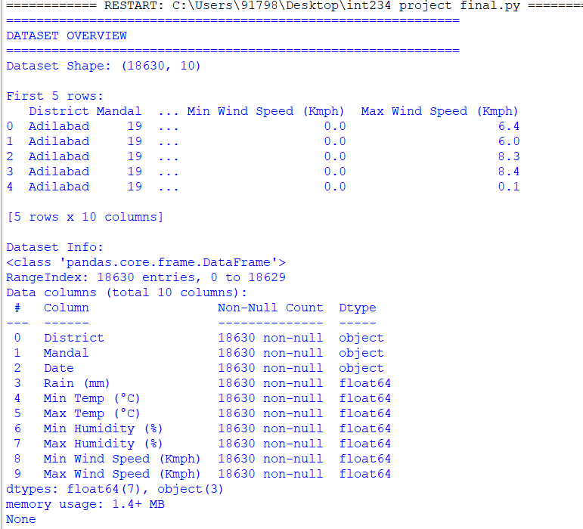
Analysis - 2: DATA PREPROCESSING:
i. Introduction:
Data preprocessing is performed to improve data quality and ensure accurate analysis. This step prepares the dataset for applying machine learning algorithms.
ii. General Description:
Missing values and duplicate records are identified and handled. Non-essential categorical columns are removed to focus on numerical weather parameters.
iii. Specific Requirements, Functions, Formulas:
Functions such as isnull().sum(), dropna(), duplicated(), and drop() are used for cleaning and feature selection.
iv. Analysis Results:
After preprocessing, the dataset becomes consistent and free from missing values, making it suitable for supervised and unsupervised learning models.
v. Visualization:
Statistical summaries and box plots are used to validate the cleaned data and observe data spread and outliers.
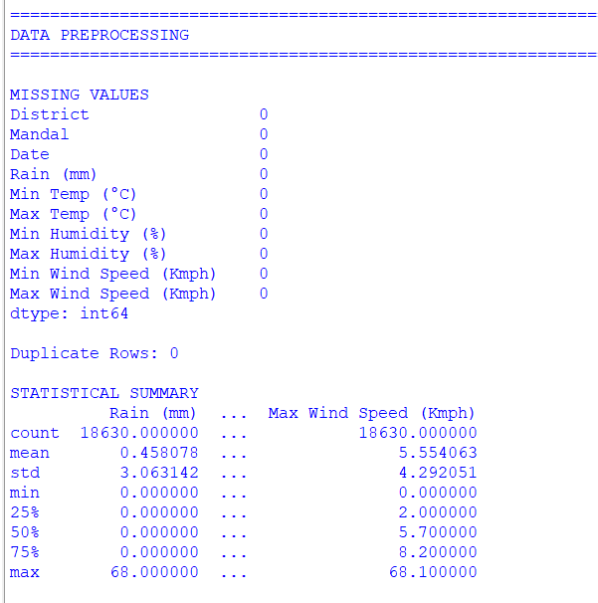
Analysis - 3: EXPLORATORY DATA ANALYSIS (EDA)
i. Introduction:
EDA is performed to explore patterns, trends, and relationships among weather variables. It supports feature selection and algorithm choice.
ii. General Description:
The analysis examines rainfall distribution and its relationship with temperature, humidity, and wind speed using visual techniques.
iii. Specific Requirements, Functions, Formulas:
Histograms, scatter plots, box plots, and correlation heatmaps are generated using Matplotlib and Seaborn.
iv. Analysis Results:
EDA reveals strong relationships between rainfall and humidity, non-linear behavior with temperature, and sufficient variability for clustering.
v. Visualization:
Histograms, scatter plots, and correlation heatmaps visually represent data distribution and inter-feature relationships.
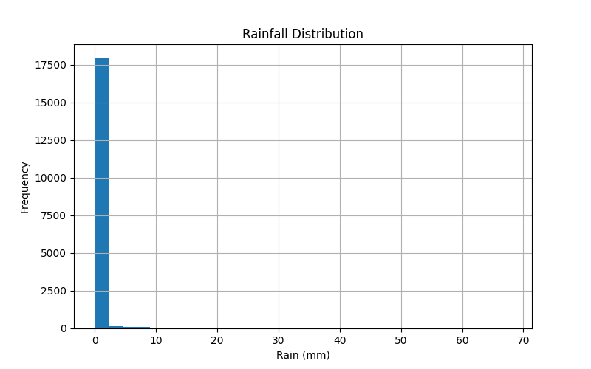
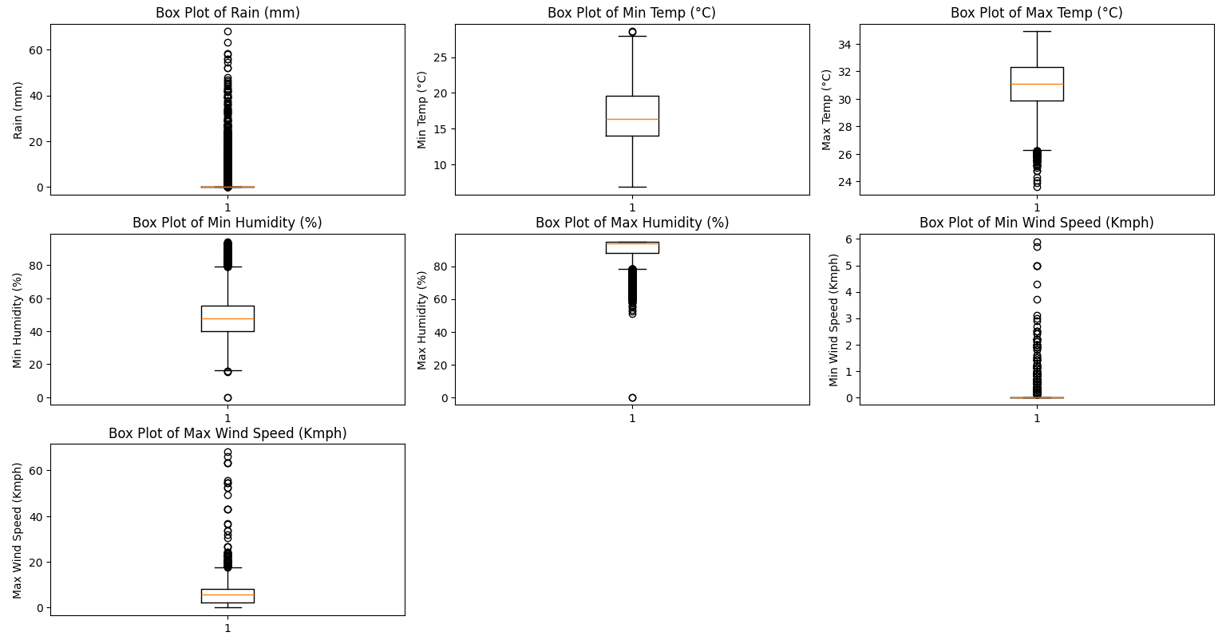
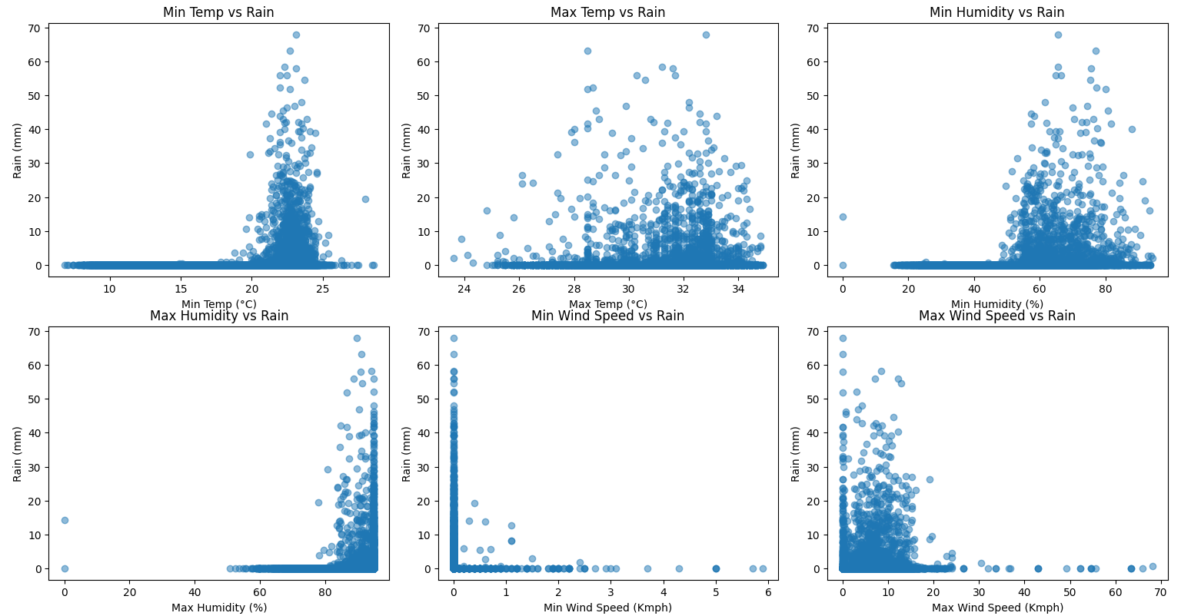

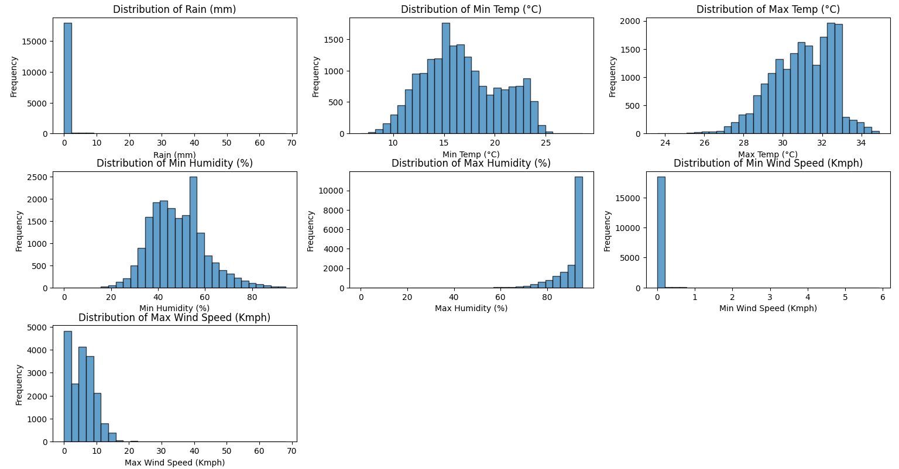
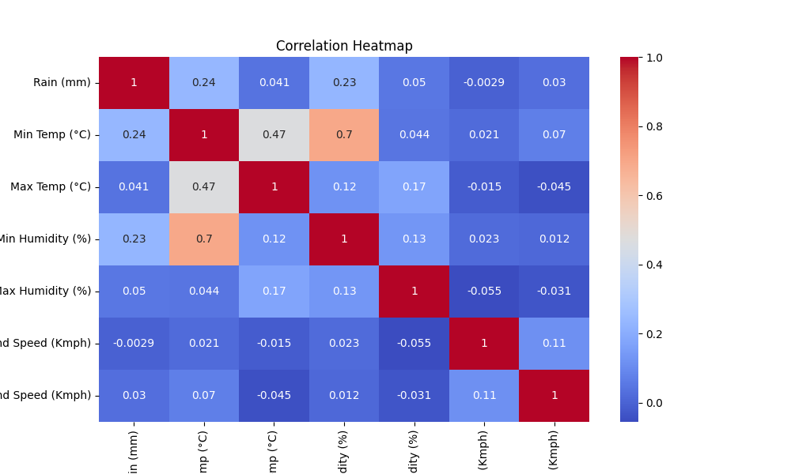
Analysis - 4: Multiple Linear Regression Analysis
i. Introduction:
This analysis applies Multiple Linear Regression to predict rainfall using multiple weather parameters such as temperature, humidity, and wind speed. It helps in understanding the combined effect of these variables on rainfall.
ii. General Description:
Rainfall is treated as the dependent variable, while temperature, humidity, and wind speed act as independent variables. The dataset is split into training and testing sets to evaluate model performance.
iii. Specific Requirements, Functions, Formulas:
The LinearRegression() model from scikit-learn is used. Model evaluation is performed using R² score, Mean Squared Error (MSE), Root Mean Squared Error (RMSE), and Mean Absolute Error (MAE).
iv. Analysis Results:
The regression model produces reasonable prediction accuracy, indicating that rainfall is influenced by multiple weather factors. Humidity and temperature contribute significantly to the prediction.
v. Visualization:
A scatter plot of actual versus predicted rainfall values is used to visualize model performance and prediction accuracy.
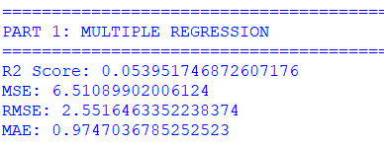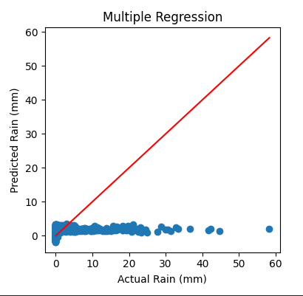
Analysis - 5: Polynomial Regression Analysis
i. Introduction:
Polynomial Regression is used to capture non-linear relationships between maximum temperature and rainfall. This method enhances prediction where linear assumptions are insufficient.
ii. General Description:
Maximum temperature is selected as the independent variable and rainfall as the dependent variable. A polynomial transformation of degree three is applied.
iii. Specific Requirements, Functions, Formulas:
The PolynomialFeatures() function is used for feature transformation, followed by LinearRegression(). Model performance is evaluated using MSE, MAE, and RMSE.
iv. Analysis Results:
The polynomial model fits the data better than a simple linear model, confirming the non-linear dependency between temperature and rainfall.
v. Visualization:
Scatter plots comparing actual and predicted rainfall values illustrate the polynomial curve fitting the data.
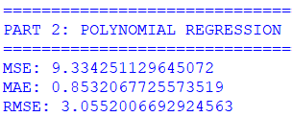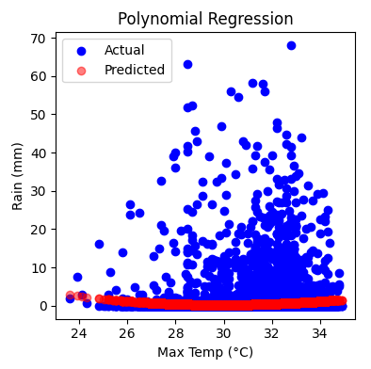
Analysis - 6: K-Nearest Neighbors (KNN) Classification Analysis
i. Introduction:
KNN classification is applied to categorize rainfall into different intensity levels. This analysis helps in understanding rainfall patterns through classification.
ii. General Description:
Rainfall values are converted into categorical classes, and weather parameters are used as features. The dataset is divided into training and testing subsets.
iii. Specific Requirements, Functions, Formulas:
The KNeighborsClassifier() algorithm is used with Minkowski distance. Model evaluation includes Accuracy, Confusion Matrix, ROC-AUC, and Log Loss.
iv. Analysis Results:
The KNN model classifies rainfall categories with acceptable accuracy, demonstrating the effectiveness of distance-based learning on weather data.
v. Visualization:
A histogram of predicted class probabilities and an accuracy versus number of neighbors (k) plot are used to analyze classifier behavior.

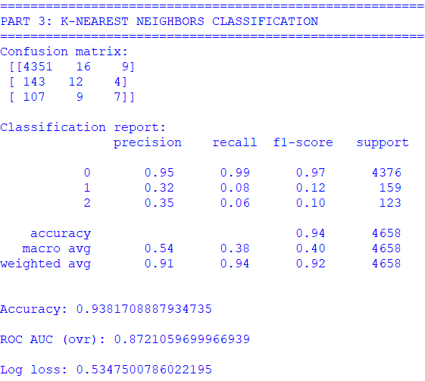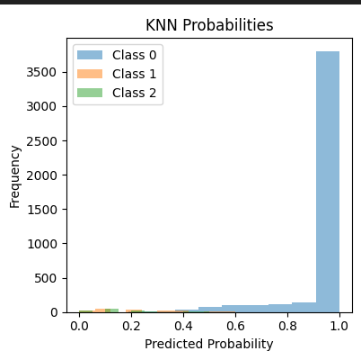
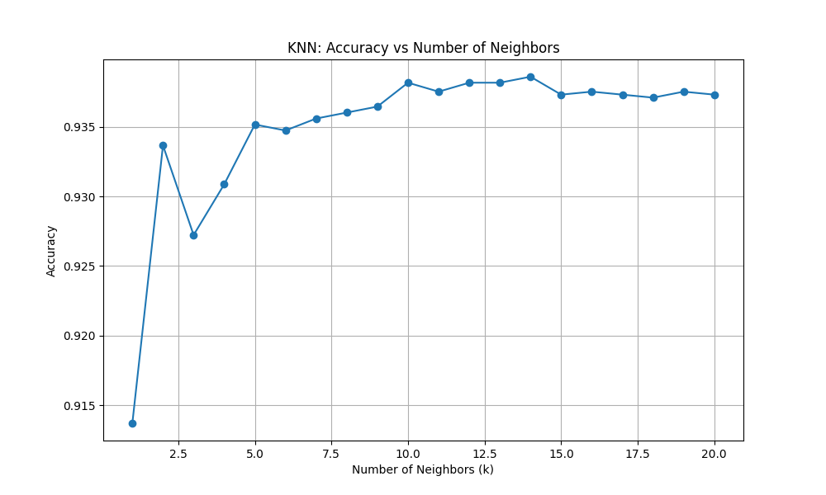

Analysis - 7: K-Means Clustering Analysis
i. Introduction:
K-Means clustering is used to group weather observations into clusters based on similarity. This helps identify distinct weather patterns.
ii. General Description:
Temperature, humidity, wind speed, and rainfall are used as clustering features. The elbow method is applied to determine the optimal number of clusters.
iii. Specific Requirements, Functions, Formulas:
The KMeans() algorithm is implemented, and within-cluster sum of squares (WCSS) is calculated to identify the optimal cluster count.
iv. Analysis Results:
The dataset is effectively grouped into clusters representing similar weather conditions. Each cluster shows distinct rainfall and temperature characteristics.
v. Visualization:
The elbow curve and a scatter plot of rainfall versus temperature colored by cluster labels are used for visualization.
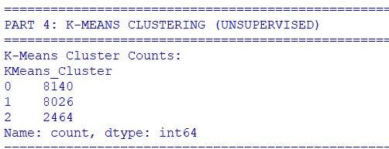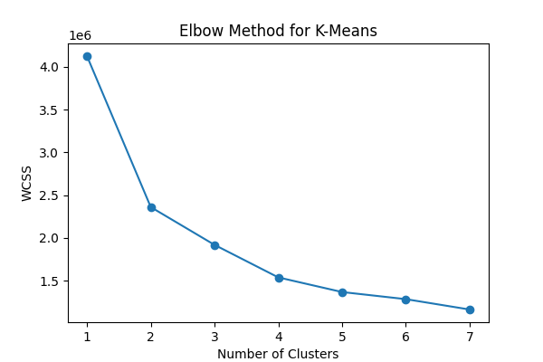

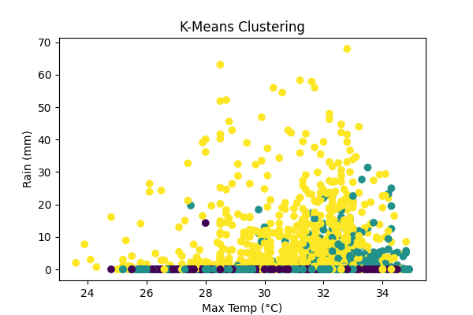

Analysis – 8 : Hierarchical Clustering Analysis
i. Introduction:
Hierarchical clustering is applied to study nested weather patterns and similarities. It provides a visual representation of cluster formation.
ii. General Description:
Agglomerative hierarchical clustering is performed using multiple linkage methods. A subset of the dataset is used for clarity in visualization.
iii. Specific Requirements, Functions, Formulas:
The linkage() and dendrogram() functions from SciPy are used with single, complete, average, centroid, and ward linkages.
iv. Analysis Results:
The dendrograms reveal hierarchical relationships and distances between weather observations, confirming the presence of structured clusters.
v. Visualization:
Dendrogram plots display how individual observations merge into clusters at different distance levels.
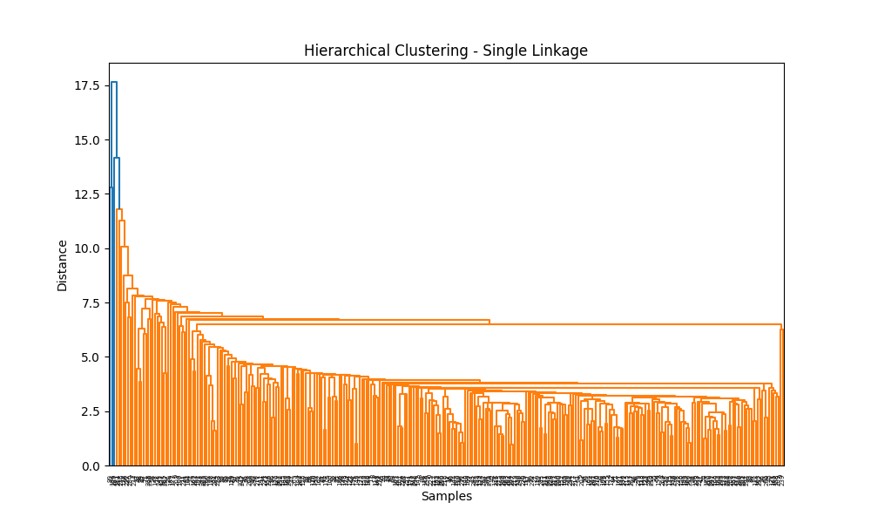
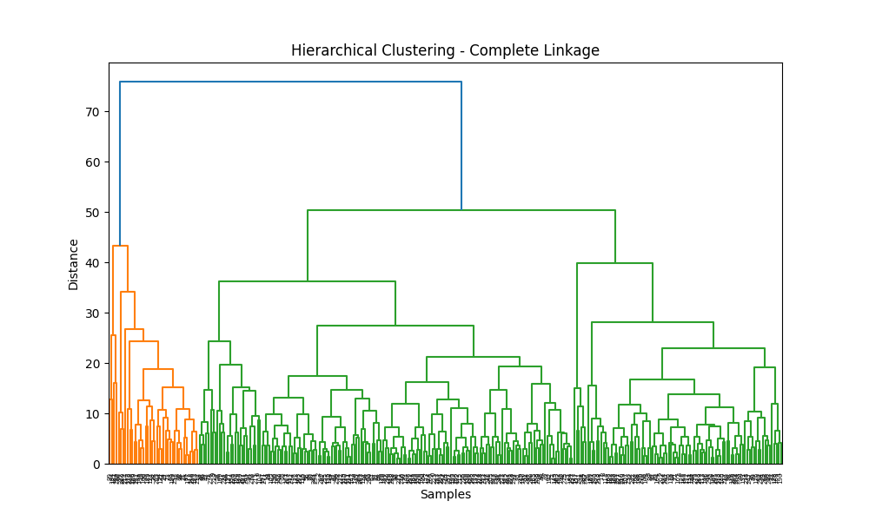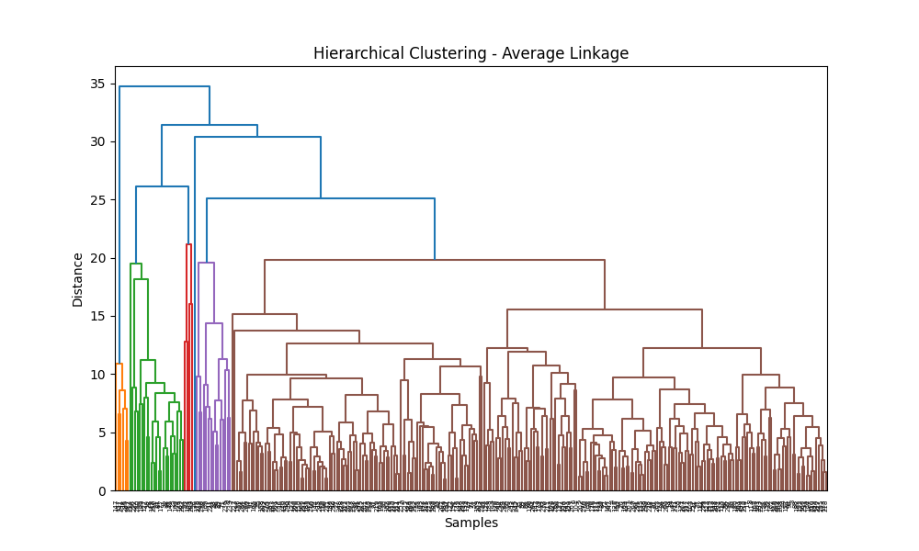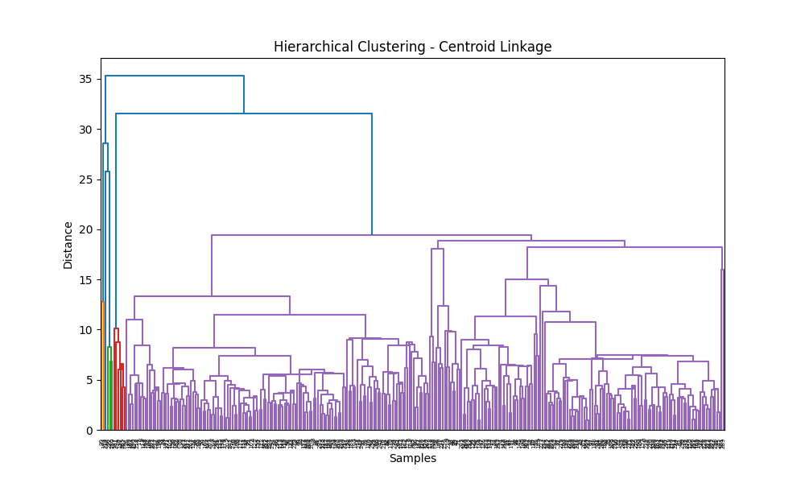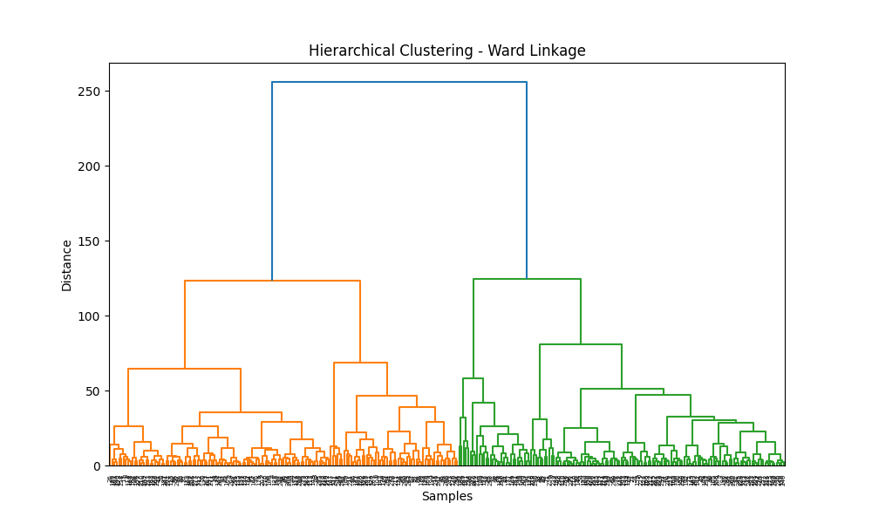
7. Conclusion:
This project successfully demonstrated the application of predictive analytics techniques on real-world Telangana weather data. Through effective data preprocessing and exploratory data analysis, meaningful relationships between rainfall and key weather parameters were identified. Supervised learning models such as Multiple Linear Regression, Polynomial Regression, and K-Nearest Neighbors provided reliable prediction and classification of rainfall patterns. Unsupervised techniques including K-Means and Hierarchical Clustering revealed hidden weather patterns and similarities among observations.
The use of evaluation metrics and visualizations helped in assessing model performance and understanding data behavior. Working with government-provided open data enhanced the practical relevance of the study. Overall, this project strengthened analytical skills and provided valuable insights into applying machine learning techniques for real-world weather analysis and decision-making.
8. Future Scope:
The scope of this project can be extended in several meaningful directions to enhance both analytical accuracy and practical applicability. One major improvement would be the inclusion of long-term historical weather data covering multiple years and seasons. Analyzing a larger time span would help in capturing seasonal trends, climate variations, and long-term rainfall patterns, leading to more robust and generalized predictive models.
Advanced machine learning and deep learning techniques such as Random Forests, Gradient Boosting, Artificial Neural Networks (ANNs), and Recurrent Neural Networks (RNNs) can be implemented to improve prediction accuracy, especially for complex and non-linear weather relationships. These models can handle high-dimensional data more effectively and provide better performance than traditional algorithms.
Another future enhancement involves integrating geographical and temporal features, such as latitude, longitude, elevation, and time-series components. This would allow spatial and temporal weather pattern analysis, improving region-specific rainfall predictions. Additionally, real-time weather data integration through APIs could enable live prediction systems for weather monitoring and alerts.
The project can also be extended to support decision-making systems for agriculture, water resource management, and disaster preparedness. Visualization dashboards using tools like Power BI or Tableau can be developed to present insights in an interactive and user-friendly manner. Overall, these extensions would transform the project from an academic study into a practical, real-world weather analytics solution.

9. References:
- Telangana Open Data Portal. Weather Data for Telangana. Available at: https://data.telangana.gov.in/
- Géron, A. (2023). Hands-On Machine Learning with Scikit-Learn, Keras, and TensorFlow (3rd ed.). O’Reilly Media.
- Müller, A. C., & Guido, S. (2017). Introduction to Machine Learning with Python: A Guide for Data Scientists. O’Reilly Media.
- Weidman, S. (2019). Deep Learning from Scratch: Building with Python from First Principles. O’Reilly Media.
- Scikit-learn Documentation. Machine Learning in Python. Available at: https://scikit-learn.org/stable/
- McKinney, W. (2017). Python for Data Analysis. O’Reilly Media.
- Hunter, J. D. (2007). Matplotlib: A 2D Graphics Environment. Computing in Science & Engineering.
- Waskom, M. L. (2021). Seaborn: Statistical Data Visualization. Journal of Open Source Software.

10. Code:
import numpy as np
import pandas as pd
from sklearn.preprocessing import PolynomialFeatures
from sklearn.linear_model import LinearRegression
from sklearn.neighbors import KNeighborsClassifier
from sklearn.metrics import r2_score, mean_squared_error, mean_absolute_error, confusion_matrix, classification_report, accuracy_score, roc_auc_score, log_loss
from sklearn.model_selection import train_test_split
import matplotlib.pyplot as plt
import seaborn as sns

df = pd.read_csv('TG Weather data November 2025.csv')
print("="*60)
print("DATASET OVERVIEW")
print("="*60)
print("Dataset Shape:", df.shape)
print("\nFirst 5 rows:")
print(df.head())
print("\nDataset Info:")
print(df.info()
print("\n" + "="*80)
print("DATA PREPROCESSING")
print("="*80)
print("\nMISSING VALUES")
print(df.isnull().sum())
df = df.dropna()
print("\nDuplicate Rows:", df.duplicated().sum())
print("\nSTATISTICAL SUMMARY")
print(df.describe())
numerical_cols = ['Rain (mm)', 'Min Temp (°C)', 'Max Temp (°C)', 'Min Humidity (%)', 'Max Humidity (%)', 'Min Wind Speed (Kmph)', 'Max Wind Speed (Kmph)']
print("\n" + "="*80)
print("EXPLORATORY DATA ANALYSIS (EDA)")
print("="*80)
plt.figure(figsize=(8,5))
df['Rain (mm)'].hist(bins=30)
plt.xlabel("Rain (mm)")
plt.ylabel("Frequency")
plt.title("Rainfall Distribution")
plt.show()
plt.figure(figsize=(15, 10))
for i, col in enumerate(numerical_cols, 1):
plt.subplot(3, 3, i)
plt.boxplot(df[col].dropna())
plt.title(f'Box Plot of {col}')
plt.ylabel(col)
plt.tight_layout()
plt.show()
plt.figure(figsize=(15, 10))
plt.subplot(2, 3, 1)
plt.scatter(df['Min Temp (°C)'], df['Rain (mm)'], alpha=0.5)
plt.xlabel('Min Temp (°C)')
plt.ylabel('Rain (mm)')
plt.title('Min Temp vs Rain')
plt.subplot(2, 3, 2)
plt.scatter(df['Max Temp (°C)'], df['Rain (mm)'], alpha=0.5)
plt.xlabel('Max Temp (°C)')
plt.ylabel('Rain (mm)')
plt.title('Max Temp vs Rain')
plt.subplot(2, 3, 3)
plt.scatter(df['Min Humidity (%)'], df['Rain (mm)'], alpha=0.5)
plt.xlabel('Min Humidity (%)')
plt.ylabel('Rain (mm)')
plt.title('Min Humidity vs Rain')
plt.subplot(2, 3, 4)
plt.scatter(df['Max Humidity (%)'], df['Rain (mm)'], alpha=0.5)
plt.xlabel('Max Humidity (%)')
plt.ylabel('Rain (mm)')
plt.title('Max Humidity vs Rain')
plt.subplot(2, 3, 5)
plt.scatter(df['Min Wind Speed (Kmph)'], df['Rain (mm)'], alpha=0.5)
plt.xlabel('Min Wind Speed (Kmph)')
plt.ylabel('Rain (mm)')
plt.title('Min Wind Speed vs Rain'
plt.subplot(2, 3, 6)
plt.scatter(df['Max Wind Speed (Kmph)'], df['Rain (mm)'], alpha=0.5)
plt.xlabel('Max Wind Speed (Kmph)')
plt.ylabel('Rain (mm)')
plt.title('Max Wind Speed vs Rain')
plt.tight_layout()
plt.show()
plt.figure(figsize=(15, 10))
for i, col in enumerate(numerical_cols, 1):
plt.subplot(3, 3, i)
plt.hist(df[col].dropna(), bins=30, edgecolor='black', alpha=0.7)
plt.title(f'Distribution of {col}')
plt.xlabel(col)
plt.ylabel('Frequency')
plt.tight_layout()
plt.show()
plt.figure(figsize=(10,6))
sns.heatmap(df.corr(numeric_only=True), annot=True, cmap='coolwarm')
plt.title("Correlation Heatmap")
plt.show()
df = df.drop(columns=['District', 'Mandal', 'Date'])
print("="*60)
print("PART 1: MULTIPLE REGRESSION")
print("="*60)
X_reg = df[['Min Temp (°C)', 'Max Temp (°C)', 'Min Humidity (%)', 'Max Humidity (%)', 'Min Wind Speed (Kmph)', 'Max Wind Speed (Kmph)']]
Y_reg = df['Rain (mm)']
X_train_reg, X_test_reg, Y_train_reg, Y_test_reg = train_test_split(X_reg, Y_reg, test_size=0.3, random_state=2)
l_model = LinearRegression()
l_model.fit(X_train_reg, Y_train_reg)
y_pred_reg = l_model.predict(X_test_reg)
r2 = r2_score(Y_test_reg, y_pred_reg)
mse = mean_squared_error(Y_test_reg, y_pred_reg)
rmse = np.sqrt(mse)
mae = mean_absolute_error(Y_test_reg, y_pred_reg)
print("R2 Score:", r2)
print("MSE:", mse)
print("RMSE:", rmse)
print("MAE:", mae)
plt.figure(figsize=(12,4))
plt.subplot(1,3,1)
plt.scatter(Y_test_reg, y_pred_reg)
plt.xlabel("Actual Rain (mm)")
plt.ylabel("Predicted Rain (mm)")
plt.title("Multiple Regression")
plt.plot([min(Y_test_reg), max(Y_test_reg)], [min(Y_test_reg), max(Y_test_reg)], color='red')
print("="*60)
print("PART 2: POLYNOMIAL REGRESSION")
print("="*60)
X_poly = df[['Max Temp (°C)']]
Y_poly = df['Rain (mm)']
poly_reg = PolynomialFeatures(degree=3)
x_pol = poly_reg.fit_transform(X_poly)
model_p = LinearRegression()
model_p.fit(x_pol, Y_poly)
y_pred_poly = model_p.predict(x_pol)
mse_poly = mean_squared_error(Y_poly, y_pred_poly)
mae_poly = mean_absolute_error(Y_poly, y_pred_poly)
rmse_poly = np.sqrt(mse_poly)
print("MSE:", mse_poly)
print("MAE:", mae_poly)
print("RMSE:", rmse_poly)
plt.subplot(1,3,2)
plt.scatter(X_poly, Y_poly, color="blue", label="Actual")
plt.scatter(X_poly, y_pred_poly, color="red", label="Predicted", alpha=0.5)
plt.xlabel("Max Temp (°C)")
plt.ylabel("Rain (mm)")
plt.title("Polynomial Regression")
plt.legend()
print("="*60)
print("PART 3: K-NEAREST NEIGHBORS CLASSIFICATION")
print("="*60)
df['Rain_Category'] = pd.cut(df['Rain (mm)'], bins=[-1, 0.1, 5, 100], labels=[0, 1, 2])
X_knn = df[['Min Temp (°C)', 'Max Temp (°C)', 'Min Humidity (%)', 'Max Humidity (%)', 'Min Wind Speed (Kmph)', 'Max Wind Speed (Kmph)']]
Y_knn = df['Rain_Category']
X_train_knn, X_test_knn, Y_train_knn, Y_test_knn = train_test_split(X_knn, Y_knn, test_size=0.25, random_state=42)
knn = KNeighborsClassifier(n_neighbors=10, metric='minkowski', p=2)
knn.fit(X_train_knn, Y_train_knn)
y_pred_knn = knn.predict(X_test_knn)
con = confusion_matrix(Y_test_knn, y_pred_knn)
rep = classification_report(Y_test_knn, y_pred_knn)
acc = accuracy_score(Y_test_knn, y_pred_knn)
y_pred_proba = knn.predict_proba(X_test_knn)
r_a = roc_auc_score(Y_test_knn, y_pred_proba, multi_class='ovr')
ll = log_loss(Y_test_knn, y_pred_proba)
print("Confusion matrix:\n", con)
print("\nClassification report:\n", rep)
print("\nAccuracy:", acc)
print("\nROC AUC (ovr):", r_a)
print("\nLog loss:", ll)
plt.subplot(1,3,3)
unique_classes = np.unique(Y_knn)
for cls in unique_classes:
plt.hist(y_pred_proba[Y_test_knn == cls, int(cls)], alpha=0.5, label=f'Class {cls}')
plt.xlabel("Predicted Probability")
plt.ylabel("Frequency")
plt.title("KNN Probabilities")
plt.legend()
plt.tight_layout()
plt.show()
plt.figure(figsize=(10, 6))
plt.plot(range(1, 21), [KNeighborsClassifier(n_neighbors=k, metric='minkowski', p=2).fit(X_train_knn, Y_train_knn).score(X_test_knn, Y_test_knn) for k in range(1, 21)], marker='o')
plt.xlabel('Number of Neighbors (k)')
plt.ylabel('Accuracy')
plt.title('KNN: Accuracy vs Number of Neighbors')
plt.grid(True)
plt.show()
from sklearn.cluster import KMeans
from scipy.cluster.hierarchy import dendrogram, linkage
print("="*60)
print("PART 4: K-MEANS CLUSTERING (UNSUPERVISED)")
print("="*60)
X_unsup = df[['Min Temp (°C)', 'Max Temp (°C)',
'Min Humidity (%)', 'Max Humidity (%)',
'Min Wind Speed (Kmph)', 'Max Wind Speed (Kmph)',
'Rain (mm)']]
wcss = []
for i in range(1, 8):
km = KMeans(n_clusters=i, random_state=42)
km.fit(X_unsup)
wcss.append(km.inertia_)
plt.figure(figsize=(6,4))
plt.plot(range(1,8), wcss, marker='o')
plt.xlabel("Number of Clusters")
plt.ylabel("WCSS")
plt.title("Elbow Method for K-Means")
plt.show()
kmeans = KMeans(n_clusters=3, random_state=42) df['KMeans_Cluster'] = kmeans.fit_predict(X_unsup)

plt.figure(figsize=(6,4))
plt.scatter(df['Max Temp (°C)'], df['Rain (mm)'], c=df['KMeans_Cluster'])
plt.xlabel("Max Temp (°C)")
plt.ylabel("Rain (mm)")
plt.title("K-Means Clustering")
plt.show()
print("K-Means Cluster Counts:")
print(df['KMeans_Cluster'].value_counts())
from scipy.cluster.hierarchy import dendrogram, linkage
print("="*60)
print("PART 5: HIERARCHICAL CLUSTERING (ALL LINKAGE METHODS)")
print("="*60)
X_unsup = df[['Min Temp (°C)', 'Max Temp (°C)',
'Min Humidity (%)', 'Max Humidity (%)',
'Min Wind Speed (Kmph)', 'Max Wind Speed (Kmph)',
'Rain (mm)']]
sample_data = X_unsup.sample(300, random_state=42)
Z_single = linkage(sample_data, method='single')
plt.figure(figsize=(10,6))
dendrogram(Z_single)
plt.title("Hierarchical Clustering - Single Linkage")
plt.xlabel("Samples")
plt.ylabel("Distance") plt.show()
Z_complete = linkage(sample_data, method='complete')
plt.figure(figsize=(10,6))
dendrogram(Z_complete)
plt.title("Hierarchical Clustering - Complete Linkage")
plt.xlabel("Samples")
plt.ylabel("Distance")
plt.show()
Z_average = linkage(sample_data, method='average')
plt.figure(figsize=(10,6))
dendrogram(Z_average)
plt.title("Hierarchical Clustering - Average Linkage")
plt.xlabel("Samples")
plt.ylabel("Distance")
plt.show()
Z_centroid = linkage(sample_data, method='centroid')
plt.figure(figsize=(10,6))
dendrogram(Z_centroid)
plt.title("Hierarchical Clustering - Centroid Linkage")
plt.xlabel("Samples")
plt.ylabel("Distance")
plt.show()
Z_ward = linkage(sample_data, method='ward')
plt.figure(figsize=(10,6))
dendrogram(Z_ward) plt.title("Hierarchical Clustering - Ward Linkage")
plt.xlabel("Samples")
plt.ylabel("Distance")
plt.show()
print("\n=== ANALYSIS COMPLETE ===")

11. Revision Tracking on GitHub and LinkedIn:
Repository Name: Predictive-Analytics-on-Telangana-Weather-Data
- GitHub Link: https://github.com/nithin-ponnuru/Predictive-Analytics-on-Telangana-Weather-Data
- LinkedIn: https://www.linkedin.com/posts/ponnuru-nithin_predictiveanalytics-machinelearning-datascience-activity-7406401521711616000-trM0?utm_source=share&utm_medium=member_desktop&rcm=ACoAAENUrU8BfsrkBZtljAwIpeLxO3CWql8aiTU

